Parallel Flow Heat Exchanger Performance

**Co-Flow Heat Exchanger Performance**

## Nathan Okey Zach Mink Randall Shobert

### ME4031W Section 6 Group 3

### 05/05/2025

## 

# **Abstract**

This work examines a performance analysis of a simple parallel flow heat exchanger, focusing on thermal effectiveness, Log Mean Temperature Difference (LMTD), and the overall heat transfer coefficient. Experimental data were collected under steady-state conditions with water as the working fluid on both the hot and cold sides. The system achieved a maximum thermal effectiveness of 13.7 ± 0.8 % at an LMTD of 73.53 ± 2.2 °C. Performance trends indicate a positive correlation between the LMTD and exchanger effectiveness and the overall heat transfer coefficient, with diminishing returns observed near the boiling point of water due to the onset of phase change and associated flow instability through the pumping system.

# **Table of Contents**

**Abstract 2**

**Table of Contents 3**

**Introduction 4**

**Materials 4**

**Methods 6**

**Results 7**

**Discussion 8**

**Conclusions 10**

**References 11**

**Appendix 12**

Section I: Figures & Tables 12

Section II: Equations 14

## 

## 

# **Introduction**

This experiment aims to determine the performance characteristics of a simple co-flow heat exchanger under varying inlet temperatures. The effectiveness and overall heat transfer coefficient of the system will be determined by measuring the temperatures at both the inlets and outlets. A wide range of temperatures will be tested with the hot side inlet ranging from room temperature, or about 22 ℃, to about 85 ℃. The cold side will be held between 0-1 ℃ using ice water, to ensure the change of 1 variable at a time. The data observed will be used to optimize the temperature difference between the inlet and outlet flows for the best system performance. Heat exchangers are used across a wide variety of applications—from small-scale systems such as computer cooling and automotive radiators to large-scale industrial processes in power generation and chemical manufacturing. Given their widespread use, improving their efficiency can lead to significant cost and energy savings.

# **Materials**

The experimental setup consisted of a benchtop concentric tube, single-pass heat exchanger, arranged in a co-flow configuration, meaning the hot and cold side flows enter and exit the exchanger on the same sides. However, the coflow configuration is inherently less effective than a counterflow configuration [1]. The co-flow configuration was chosen out of necessity, as the pumps chosen could not sustain enough head pressure to operate in a counterflow configuration. The exchanger was constructed with two lengths of stainless steel tubing, 2” ID (cold side) and ¼” ID (hot side), see Figure 1 for reference. The working length of the exchanger was 18”, with the ends supported by steel plates, with the two concentric tubes adhered to the end plates using JB Weld.

Water was used as the working fluid for both the hot and cold sides. Two identical fish tank pumps, rated for 80 GPM, were used to pump from the hot and cold reservoirs. The system

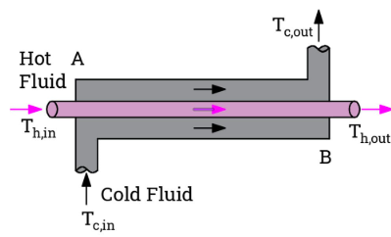

Figure 1: *Schematic of the co-flow heat exchanger used during experiments*

effectively consisted of two open fluid loops, as the return line from each side of the exchanger was placed into its respective reservoirs. Ice was used to cool the cold side down to a desired cold side temperature of 0 °C, and a 1 kW immersion heater was used to heat the hot side to a range of temperatures, from 22 °C to 84 °C. Temperatures at each inlet and outlet were monitored using 4 Type K thermocouples, driven by 4 separate operational amplifiers (Fig. 3), with a target gain of 100x. A reference temperature was determined using an OMEGA 44005 thermistor, calibrated using Equation 5. This thermistor has a resistance of 3000 Ohms at a temperature of 25 ℃. A cold junction compensation circuit (CJC) could not be used in this setup, since all four analog input channels [2] on the DAQ were occupied by the thermocouple amplifiers. A custom LabVIEW VI was created for temperature monitoring and data logging, with a chosen sampling count of 10 samples at 100 Hz.

# **Methods**

The performance of the co-flow heat exchanger was evaluated experimentally at the hot and cold side temperatures in Table 1. Each hot side temperature set point was manually controlled with the immersion heater within ± 0.5 °C. The cold side temperature was held in the range $0°C<T_{ci}<1°C$. The pumps were adjusted to their maximum flow rates, measured to be 0.006 ± [0.0005] kg/s. The inlet and outlet temperatures of both sides were logged for a minimum of two minutes once the two inlet temperatures reached steady-state values. The temperature signals were averaged every 10 samples to maintain good signal quality for data analysis.

The metrics chosen to characterize the performance of the exchanger were the effectiveness (𝜀), overall heat transfer coefficient (U), and the maximum rate of heat transfer (qmax). See Equations 1-3 for correlations. The thermistor CJC was implemented into the LabVIEW VI. Since thermocouples operate on temperature differences [3], the compensated thermistor temperature was added to each of the 4 inlet and outlet temperature signals. The compensated temperature is calculated by the LabVIEW VI using Equation 5, by measuring $R_{2}$ and plugging in a given $β=3553 K$, and a known resistance value $R_{1}=3553Ω$ at 21°C.

# **Results**

Due to each test being run for two minutes, the average temperature was taken for each of the 4 thermocouple readings over the run time. The graphs show an upward trend in maximum heat transfer rate, effectiveness, and overall heat transfer coefficient as LMTD increases. Figure 2, seen below, shows the effectiveness of the hot side of the heat exchanger as a function of LMTD. This same correlation is also seen in figures 4 and 5 of the appendix within their respective graphs. LMTD is the log-mean temperature difference of the system and is calculated using equation 1 of Appendix II. 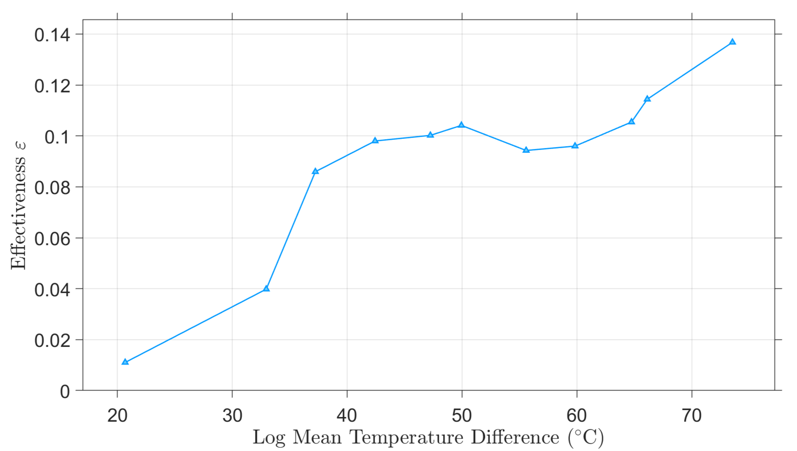

Figure 2: *Co-flow heat exchanger effectiveness as a function of LMTD with constant mass flow rate.*

The minimum values for each were found at LMTD of 20.68 ± 2.2°C, and those values were 6.41 ± 0.9 W, 1.10 ± 0.1%, and 1.88 ± 0.2 (W‧m-2‧K-1), respectively. The maximum values for each were found at an LMTD of 73.53 ± 2.2°C, and those values were 308.2 ± 25 W, 13.7 ± 0.8%, and 25.44 ± 2 (W‧m-2‧K-1), respectively. The results follow the general trend of the equations, which is that as the temperature difference between hot and cold goes up, the effectiveness of the system rises as well. There is an unexpected trend in the data from LMTD of 37°C to 50°C, where the values calculated rise significantly before decreasing back to approximately linear at 55°C. The data for each testing temperature can be found in Appendix I in Table 2.

# **Discussion**

There are 3 main sources of uncertainty in this experiment. The first is from the type K thermocouples, which have an uncertainty of 2.2 ℃ [3]. There is also uncertainty in the area measurement, as the caliper used to measure the radius had an uncertainty of 0.0005 inches [6]. The last uncertainty is from the mass flow measurement, which was determined to be 50% of the smallest measurement from the graduated cylinder. Since the smallest level of measurement was 1 mL, this value was 0.5 mL/s, which was then changed into our mass flow values, becoming 0.0005 kg/s.

The uncertainty values were calculated using equations 6-14 from Appendix II. It was found that the majority of all uncertainty values came from the thermocouple uncertainty in the tests where the hot side temperature was relatively low. In the higher temperature trials, the majority of the uncertainty came from the mass transfer uncertainty. This intuitively makes sense because the 2.2 ℃ makes up a much larger portion of the temperature measurement than the other uncertainties in their respective measurements. The random uncertainty was quite small as well, due to the number of samples taken being between 1000-2000. Due to the nonlinearity of the graph, the linear regression uncertainty was not added, as it would be very difficult to get an accurate value for it because of the low R2 value of the line. This low value suggests our data is not very linear, which can be seen on the graph due to the middle 4 data points. Although the middle 4 data points do not fit exactly with the rest of the data, the general trend still remains that as the LMTD of the system increases, the effectiveness of the system will increase.

If future experiments were to be done with this setup, a few changes could be made to help to make the data more linear. Primarily, using a copper tube for the hot side would allow for more heat transfer from the hot side to the cold side. Stainless steel was used, which has a thermal conductivity of 14.4 $\frac{W}{m*K}$, while copper has a thermal conductivity of 111 $\frac{W}{m*K}$ [5]. This means the copper transfers heat through the pipe itself almost 10x better than the stainless steel does. Another solution to achieve more uniform data is to increase the diameter of the hot side tube. Currently, the hot side tube has a diameter of ¼” while the cold side has a diameter of 2”. Increasing the diameter would increase the heat transfer between the hot and cold sides, while also increasing the amount of cold side water in contact with the hot side tube. One other improvement to the system would be to change the undersized fish tank pumps. In its current configuration, the pumps are functional, but the low power and associated head pressure of these pumps cause issues with slow flow through the cold side. If more powerful pumps were used, there would be no stagnant water on the cold side, and the exchanger would be significantly more effective.

# **Conclusions**

After testing and analysis, it was found that the maximum system effectiveness is achieved with the highest possible LMTD. The peak effectiveness observed was 13.7 ± 0.8% at an LMTD of 73.53 ± 2.2 °C. This means that the original hypothesis was correct, that efficiency would increase with temperature. This would most likely stay true until 100 °C, beyond which the pumps designed for incompressible water would vapor lock and render the pump ineffective. Other possible tests to be run with this setup could be to test the effect of increasing the hot side surface area. Increasing the hot tube diameter should also boost effectiveness, as it appears in the numerator of the effectiveness equation.

## 

# **References**

[1] Frank P. Incropera and David P. DeWit. Fundamentals of Heat and Mass Transfer. John Wiley & Sons, Inc., fourth edition, 1996.

[[2]](http://www.ni.com/docs/en-US/bundle/usb-6001-specs/resource/374369a.pdf) National Instruments, “NI USB-6001 Specifications”, 374369A-01 datasheet, May 2014 [Revised Feb. 2023].

[[3]](http://mx.omega.com/temperature/Z/pdf/z021-032.pdf) Omega Engineering, “Thermoelement Material T-30-Z”, Z 21-32

[[4]](https://www.farnell.com/datasheets/2918128.pdf) Farnell, “Thermistor Elements”, 2918128 datasheet

[[5]](https://www.engineeringtoolbox.com/thermal-conductivity-metals-d_858.html) “Thermal Conductivity of Metals and Alloys: Data Table & Reference Guide.”, Engineering Toolbox, March 2025.

[[6]](https://www.mitutoyo.com/webfoo/wp-content/uploads/2129-AOS-Calipers.pdf) Mitutoyo, “AOS Absolute Digimatic Caliper, CD-AX/APX Series”, 2129 bulletin, Feb. 2014

## 

# **Appendix**

## **Section I: Figures & Tables**

Figure 3: Schematic diagram of the OP-amp circuit used with thermocouples

| Hot Side ( °C) | 22 | 35 | 40 | 45 | 50 | 55 | 60 | 65 | 70 | 74 | 82 |
| --- | --- | --- | --- | --- | --- | --- | --- | --- | --- | --- | --- |
| Cold Side ( °C) | 0 | 0 | 0 | 0 | 0 | 0 | 0 | 0 | 0 | 0 | 0 |

Table 1: *Test Matrix*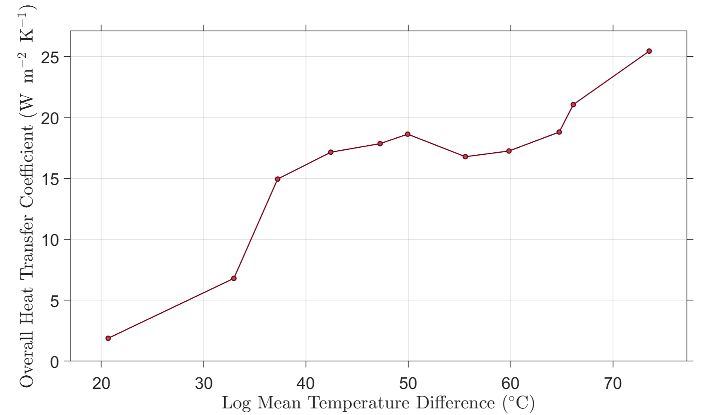

Figure 4: Effect of LMTD on the overall heat transfer coefficient for a co-flow heat exchanger.

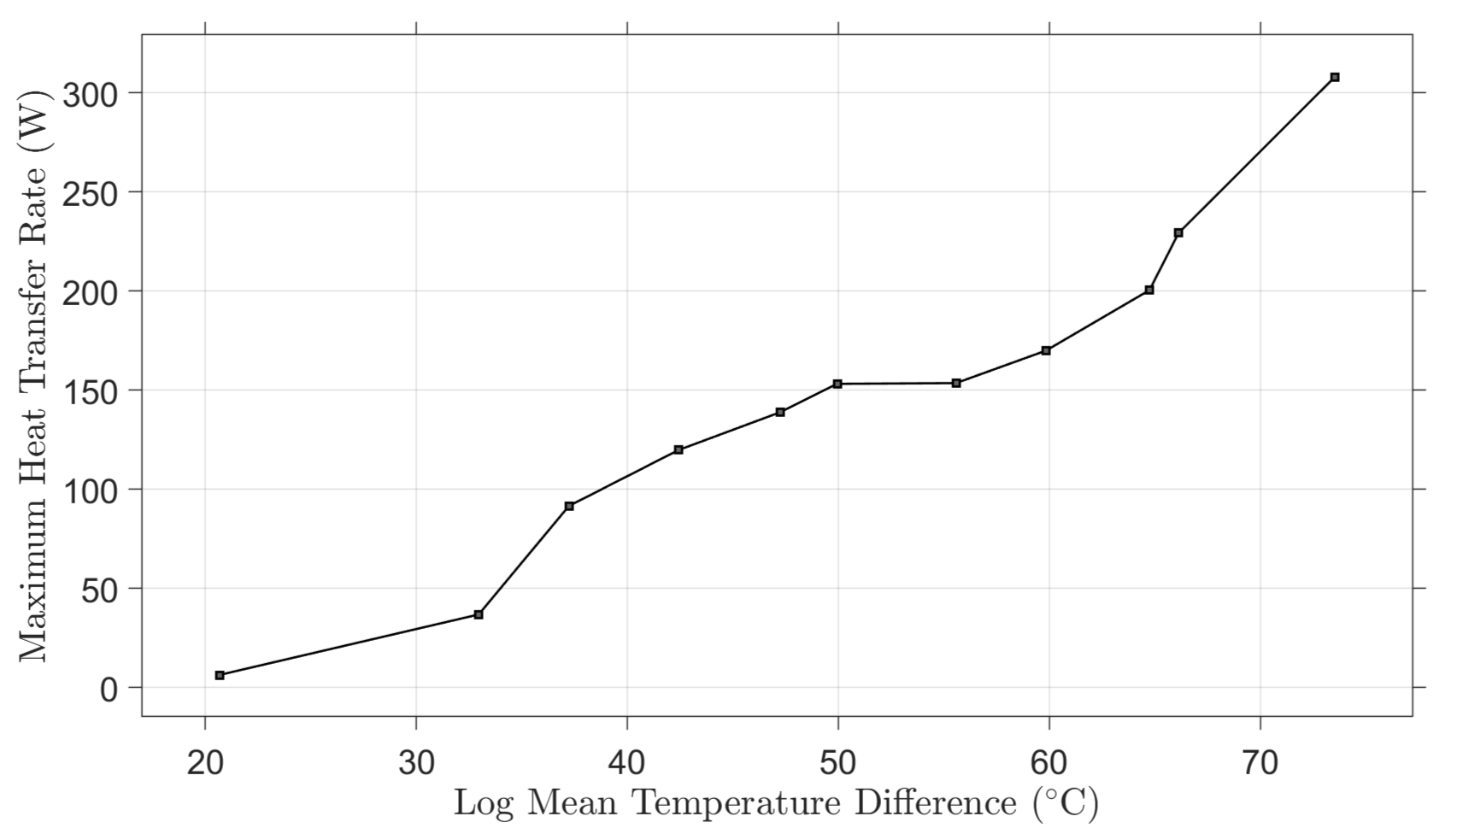

Figure 5: Effect of log-mean-temperature-difference (LMTD) on the theoretical maximum heat transfer rate.

| Units | (C) | (C) | (C) | (J/kgK) | (W) | (W/m^2K) | (-) |
| --- | --- | --- | --- | --- | --- | --- | --- |
|  | Delta IN | LMTD | Hot Deltas | Cp | Theoretical q_max | U | Effectiveness |
| 22 | 21.275 | 20.681 | 0.235 | 4177 | 6.4142 | 1.8831 | 0.0110 |
| 35 | 33.919 | 32.959 | 1.351 | 4178 | 36.9019 | 6.7980 | 0.0398 |
| 40 | 39.027 | 37.233 | 3.354 | 4178 | 91.6372 | 14.9433 | 0.0859 |
| 45 | 44.749 | 42.430 | 4.386 | 4179 | 119.8628 | 17.1521 | 0.0980 |
| 50 | 50.697 | 47.244 | 5.080 | 4181.26 | 138.9240 | 17.8539 | 0.1002 |
| 55 | 53.812 | 49.943 | 5.604 | 4182 | 153.2596 | 18.6322 | 0.1041 |
| 60 | 59.531 | 55.577 | 5.613 | 4185 | 153.6208 | 16.7826 | 0.0943 |
| 65 | 64.684 | 59.832 | 6.209 | 4186 | 169.9816 | 17.2493 | 0.0960 |
| 70 | 69.406 | 64.745 | 7.318 | 4190 | 200.5212 | 18.8044 | 0.1054 |
| 74 | 73.108 | 66.118 | 8.363 | 4192 | 229.2840 | 21.0551 | 0.1144 |
| 82 | 82.075 | 73.534 | 11.224 | 4198 | 308.1537 | 25.4441 | 0.1368 |

Table 2: Table of all calculated values from each trial

## **Section II: Equations**

$LMTD = \frac{(Thi-Tci)-(Tho-Tco)}{ln(\frac{Thi-Tci}{Tho-Tco})}$ [1]

$U=\frac{ṁc_{p}(Thi-Tho)}{A_{s}⋅LMTD}$ [2]

$ε=\frac{U⋅A_{s}⋅LMTD}{ṁ⋅c_{p}(Thi-Tho)}$ [3]

$Q_{max}(Theory)=ṁC_{p}(Thi-Tho)$ [4]

$T_{CJC}=\frac{βT_{1}}{β-T_{1}ln(\frac{R_{1}}{R_{2}})}$ [5]

$ṁ Uncertainty for U:\frac{c_{p}(Thi-Tho)}{A_{s}⋅LMTD}⋅U(ṁ)$ [6]

$A_{s} Uncertainty for U:\frac{-ṁc_{p}(Thi-Tho)}{{A_{s}}^{2}⋅LMTD}⋅U(A_{s})$ [7]

$ΔT Uncertainty for U:\frac{ṁc_{p}}{{A_{s}}^{}⋅LMTD}⋅U(ΔT)$ [8]

$ṁ Uncertainty for ε:\frac{-U⋅A_{s}⋅LMTD}{ṁ^{2}c_{p}(Thi-Tho)}⋅U(ṁ)$ [9]

$A_{s} Uncertainty for ε:\frac{U⋅LMTD}{ṁc_{p}(Thi-Tho)}⋅U(A_{s})$ [10]

$ΔT Uncertainty for ε:\frac{-U{⋅A}_{s}⋅LMTD}{ṁc_{p}(ΔT)^{2}}⋅U(ΔT)$ [11]

$ṁ Uncertainty for Q:C_{p}(Thi-Tho)⋅U(ṁ)$ [12]

$ΔT Uncertainty for Q:ṁ⋅C_{p}⋅U(ΔT)$ [13]

$Random Uncertainty=1.96\frac{std}{\sqrt{n}}$ [14]